THE SOCIETY OF JESUS CHRIST

HOLY PASCHA
PASTORAL LETTER
A.D. 2017

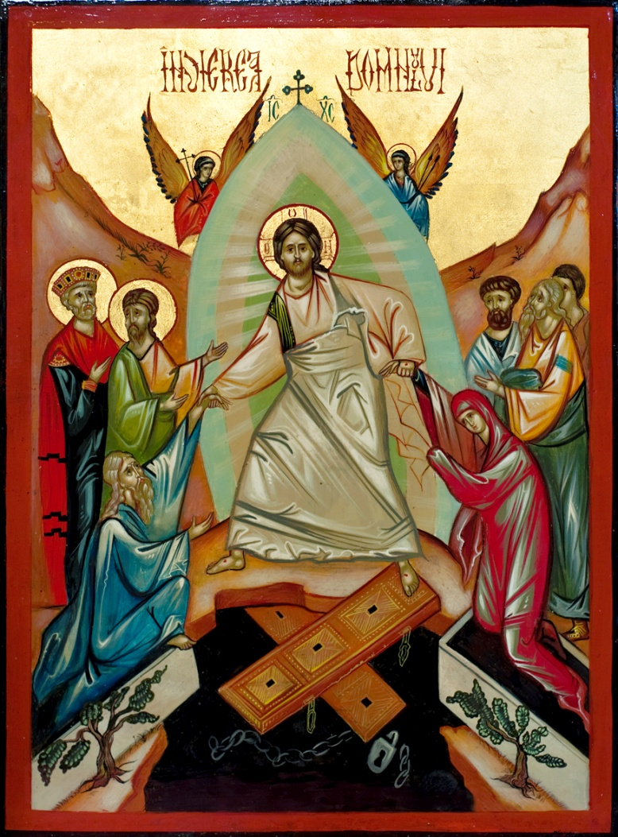

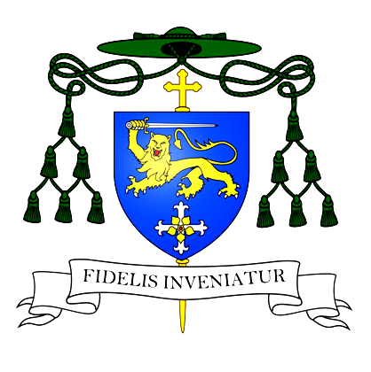
Dear Brothers and Sisters in Christ,
CHRIST IS RISEN!
With the help of our blessed and merciful Lord, we have arrived once more to the most significant event in the history of the Cosmos: The Holy Resurection of our Lord and Saviour Jesus Christ.When contemplating the reality of death in the natural world, and in particularily the mistery of our own death, it is impossible not to ask ourselves the most foundamental of all questions: Why is the Resurection of Jesus Christ important for us? What is the meaning of it and what is the purpose of our lives?
The Holy Mother Church teaches us the answer for this questions; the death and Resurection of Christ forshadows our own deth and resurection. St. Paul the Apostle tells us: "Christ has indeed been raised from the dead, the firstfruits of those who have fallen asleep" (I Cor. 15, 20). As Christ rose from the dead so will we. But resurrection is not exclusively restricted to the afterlife. St. Clement of Alexandria underlines that the resurrection takes place through an intimate spiritual knowledge of Christ's Mysteries while still in this life. This process of "spiritual awakening" is called by the Fathers of the Church "Gnosis" (Borella, 2001) .
The present- here and now lived in Christ Jesus- is the one that transforms our lives, as St. Paul tells us: "Today, if you hear his voice, do not harden your hearts" (Hebrews 3:7). Tomorrow does not belong to us; it belongs to God. Only the moment is ours. "Carpe diem/seize the day" wisely warned the Romans! It is because of the reality of our ephemeral and unpredictable lives that it is so important to orient our lives towards the Risen Christ today.
One of the Romanian mystics, Fr. Arsenie Boca once said: "Brothers do not believe for a moment that you will inherit after death The Kingdom which you have failed to mirror while in your earthly lives!" Fr. Boca wanted to underline that both, the realities of heavens and hell, start while still in this terrestrial life. Since the very beginning Man's purpose was deification/theosis. The eternal life is only a continuation of what we have labored to earn through Christ's mercy and sacrifice on the Cross, in this present life (Philippians 2:12). The knowledge of God and the inheritance of the Kingdom of Heaven, the eternal life in the Kingdom of Light are earned by fighting against the evil that is in us and in the world, through being soldiers of the spiritual Army of Jesus Christ. They are earned by fighting the daily spiritual warfare and gaining the crown of celestial glory ( Ephesians 6: 10-20). Theosis( becoming Christ like) is possible exclusively because of the death of resurrection of Jesus. Deification, immortality and eternal bliss in the Kingdom of Heaven is our final purpose. This purifying process starts while in this earthly life.
Joseph Campbell a American mythologist once said that if we harden our hearts and refuse to understand the message of Christ here and now, if we decide in our inner selves to have no ears to hear and no eyes to see the Mystery of Christ's Resurrection (mirrored in our neighbor) while in this life, then we will certainly fail to know Jesus Christ both in this life and the next. An intimate knowing of Jesus, becoming Christ like starts here, and it continues into the hereafter.
We rise from spiritual death every time we do the good and choose to forgive and love our neighbor by the power of the Risen Jesus and the strength of the Holy Spirit manifested in the Holy Mysteries/Sacraments of Christ's Church. Jesus Christ accomplished it all for us (John 19:30). Salvation is a gift because of Jesus Christ's Resurrection, yet we need to accept this most holy gift. God can never operate against our free will, and it is ours to accept or reject the Gift of Salvation earned with a tremendous price of blood on the Holy Cross. Satan has lost the fight, in the biggest plan of God the devil is defeated and is only a tolerated being with a clear mission designed by God: to separate the wheat from the tares (Matthew 13: 24-30). Christ has trampled and destroyed death by death. All we need to do as Christ's brothers and sisters, beloved ones, is is to embrace our own cross and follow Christ with courage and persistence. Although salvation is a free gift it comes with tremendous responsibility and the exercising of our God endowed free will. The choice of where we want to spend eternity is exclusively ours. God the Father, the Creator of Heaven and Earth, is clear in the Old Testament about this frightening choice and reality that awaits every soul: "This day I call the heavens and the earth as witnesses against you that I have set before you life and death, blessings and curses. Now choose life, so that you and your children may live " (Deuteronomy 30: 18-19). We make this choice of where to spend eternity through our deeds, here and now- today, every day of our lives. At the Last Judgment our Lord Jesus Christ will only confirm after our deaths what we have chosen while still in our earthly existences. So then beloved brothers and sisters, let us choose today Jesus Christ. Let us choose the blessing of God, life and the light of Jesus Christ crucified and risen from the dead!
Hope is the meaning of Christ's Resurrection. Most certainly in our wretched world marked by apocalyptical signs and rehearsals for the end of days, all of which such signs precede the Return of Jesus Christ, there is a desperate need for hope. We as Christians must be PEOPLE OF THE RESURECTION/EASTER PEOPLE, and model the high hopes and promises of life eternal which our Lord Jesus Chris has made to all that follow Him. The hope and promises of life eternal which Christ Himself has made us, must keep us strong and courageous in spite of all evil, adversity and the snares of the evil one.
The Resurrection of Christ Jesus is the source of our own theosis (deification), the regeneration of the whole Universe, and the fulfillment of the history of humanity and the Cosmos. The true sacrifice of Jesus Christ was His decision to incarnate and undergo the suffering and the agony of the human condition, and die a horrendous death in the flesh nailed on the Holy Cross. Professing the birth, life, death and resurrection in the flesh is our sacred mission as Christians (John 1:14). The Mystery of Incarnation is the most misunderstood and furiously attacked today all over the world by the false "Gnostics" and the gates of hell. Denying the Truth of Christ's Incarnation in the flesh and its bodily passion and resurrection is luciferian at its core, and very perilous for the souls! We must therefore stand up for The Truth of all Ages, of the Orthodox-Catholic faith which the Church teaches, that indeed "for us and our salvation", Jesus Christ "was crucified under Pontius Pilate; he suffered death and was buried. On the third day he rose again in accordance with the Scriptures; he ascended into heaven and is seated at the right hand of the Father. He will come again in glory to judge the living and the dead,
and his kingdom will have no end" (The Nicene-Constantinopolitan Creed). Let us profess ourselves then this true and infinitely costly Sacrifice of Christ in the flesh on the Cross, and the Resurrection in the body, a sacrifice above any sacrifice (1 Corinthians 7:23). It is because of this sacrifice and the Lord's resurrection (that Christ Jesus solely can grant!), that we have hope. To honor this tremendous price of blood paid by our Lord and Savior Jesus Christ on the Cross let us change our lives for better today.
We implore the Lord of Life, the King of Compassion and Glory to bless each of you. To bless your families, your houses, your everyday existences and your whole lives through His Holy Resurrection. We beseech the Lord to prepare for us a small corner in His Kingdom, to grant us resurrection from the death of the spirit, the life of the world to come and liberation from under the yoke of sin and the terror of death. Today when we hear the Gospel of Christ's Holy Resurrection, let us change our hearts and lives according to His holiness and resurrection, as people of the New Covenant!
I send you below the powerful and holy words of St. John the Chrysostom, which call us all to repentance, forgiveness and resurrection. May Jesus Christ risen from the dead bless you and yours and sustain you always.
In the Light of Christ Jesus crucified and risen from the dead, I send you my blessings.
I wish you all, a holy and blessed Easter!
CHRIST IS RISEN! INDEED HE IS RISEN!
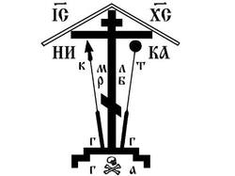Marius Nicolas
By the mercy of God and grace of our Lord Jesus Christ, Orthodox-Catholic Bishop.

Holy Resurection Pastoral Letter given in the 4th year of our episcopate.
4/16/A.D. 2017
Southfiled, Michigan , United Staes of America

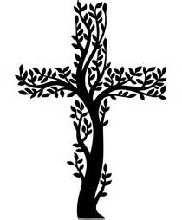

Pascha Homily
by St. John Chrysostom
Let all pious men and all lovers of God rejoice in the splendor of this feast; let the wise servants blissfully enter into the joy of their Lord; let those who have borne the burden of Lent now receive their pay, and those who have toiled since the first hour, let them now receive their due reward; let any who came after the third hour be grateful to join in the feast, and those who may have come after the sixth, let them not be afraid of being too late; for the Lord is gracious and He receives the last even as the first. He gives rest to him who comes on the eleventh hour as well as to him who has toiled since the first: yes, He has pity on the last and He serves the first; He rewards the one and praises the effort.
Come you all: enter into the joy of your Lord. You the first and you the last, receive alike your reward; you rich and you poor, dance together; you sober and you weaklings, celebrate the day; you who have kept the fast and you who have not, rejoice today. The table is richly loaded: enjoy its royal banquet. The calf is a fatted one: let no one go away hungry. All of you enjoy the banquet of faith; all of you receive the riches of his goodness. Let no one grieve over his poverty, for the universal kingdom has been revealed; let no one weep over his sins, for pardon has shone from the grave; let no one fear death, for the death of our Savior has set us free: He has destroyed it by enduring it, He has despoiled Hades by going down into its kingdom, He has angered it by allowing it to taste of his flesh.
When Isaiah foresaw all this, he cried out: "O Hades, you have been angered by encountering Him in the nether world." Hades is angered because frustrated, it is angered because it has been mocked, it is angered because it has been destroyed, it is angered because it has been reduced to naught, it is angered because it is now captive. It seized a body, and, lo! it encountered heaven; it seized the visible, and was overcome by the invisible.
O death, where is your sting? O Hades, where is your victory? Christ is risen and you are abolished. Christ is risen and the demons are cast down. Christ is risen and the angels rejoice. Christ is risen and life is freed. Christ is risen and the tomb is emptied of the dead: for Christ, being risen from the dead, has become the Leader and Reviver of those who had fallen asleep. To Him be glory and power forever and ever. Amen.

References:
The Secret of the Christian Way: A Contemplative Ascent Through the Writings of Jean Borella (Suny Series in Western Esoteric Traditions), State University of New York Press Albany (2001).

